Web Based Application Project
Group Number: 9
Assigned Challenge: Campus Carpool & Transportation Solution

Name | Surname | Student No
Ngwanelihle | Ngwane | 22383789
Josh David | Chettiar | 22464287
Sinakhokonke | Mbhele | 22474683
Londeka Ayanda | Hadebe | 22319693
Sphephile | Kuzwayo | 22176277
Simayedwa | Cele | 22494496
Fezeka | Makhetha | 22115335
Nobuhle | Mndiyata | 22359726
Luthando | Bhulose | 22423892
Mnelisi | Mteshane | 22319598
Amahle Azandiswe | Zungu | 22216328
Angel Nondumiso | Luthuli | 22445362

2. Introduction

Brief overview:

Students as well as staff are currently fighting the constant struggle with unreliable transportation, limited parking space in campus parking spaces and the excessive costs of commuting alone. Without a central digital system, it is difficult to coordinate rides or know exactly when campus shuttles will arrive, leading to wasted time and increased pollution.
This web-based application solves these issues by providing a safe, verified platform for carpooling and real-time transit updates. By using a digital system, it makes it easier to share rides and track campus buses, the application will reduce campus traffic, lowers travel expenses, and will support a greener and safer campus environment. An effective digital solution is necessary to turn a stressful daily commute into an easier, organised, and sustainable experience for university students and staff.

Proposed solution:
This project proposes a smart campus transportation management system designed to improve mobility, safety, and sustainability for students and staff. The system integrates ridesharing, automated carpool scheduling, and real-time transport notifications into a single secure digital platform. Which allows for a smoother more efficient journey home.

3. Problem statement and objectives:
Students and staff face daily campus transportation challenges due to limited, uncoordinated, and hard-to-track transport options. This leads to delays, safety concerns, high costs, and missed activities, especially during peak times or late hours. The lack of a centralized, secure platform also makes ride-sharing difficult and unreliable.
The solution is to develop a Smart Campus Transportation Management System—a secure, web-based platform that enables verified users to post and find rides, book seats, share costs, track shuttles in real time, and receive notifications and emergency alerts, while ensuring safety and compliance with POPIA.
The transportation problem affects multiple groups within the campus community:
Students: Most impacted due to reliance on affordable, reliable transport for classes and activities, especially those off-campus or traveling at night.
Staff Members: Face disruptions to lectures, meetings, and daily unreliable transport.
Shuttle Operators/Administrators: Struggle to manage routes, schedules, and communicate updates without a centralized system.
Ride-Sharing Users (Drivers & Passengers): Experience safety and trust issues without proper verification and booking systems.
The Institution: Affected through reduced punctuality, safety concerns, and a poorer overall campus experience

The proposed system will provide:

Ride-Sharing Platform
- Staff and students may register as passengers or drivers.
- Users can seek transportation or post rides that are available.
- Commuters going in the same direction are connected by matching features.
- Using campus credentials, users can be securely verified.

Carpool Scheduling
- Plan regular excursions, such morning workshops every day.
- Location, time, and route-based automated matching.
- An electronic system for reservations and confirmation.
- The ability to precisely divide gasoline expenses.

Campus Transport Notifications
- Schedule updates for campus shuttles in real time.
- Alerts on cancellations, route modifications, or delays.
- Emergency notifications about interruptions pertaining to transportation.
- Integration with announcements on campus.
Benefits of the Solution for Students & Staff:
- Lower transportation expenses
- Better time management and convenience
- Enhanced security thanks to verified users
- Transportation information is easier to obtain For the Organization
- Less traffic in parking lots
- A smaller carbon footprint on campus
- Better sustainability efforts on campus
- A better overall experience for staff and students
Key Features
- Safe login using a staff or student ID
- An easy-to-use dashboard
- Web design that adapts to mobile devices
- The algorithm for route matching
- An accountability rating and feedback system

4. Methodology
Methodology (Crystal Yellow)
The Smart Campus Transportation Management System was developed using the Crystal Yellow Agile methodology. Crystal Yellow is a lightweight agile approach that works well for small teams because it focuses on team collaboration, flexible roles, regular communication, and building the system in small stages. This made it suitable for our project since the team worked on different parts of the system at the same time and needed to coordinate closely.
Student Number | Initial & Surname | To do | Part of System
22445362 | AN Luthuli | Documentation | Section 3,4,6,7,8 ,9,12
22464287 | JD Chettiar | Documentation | Section 1,5,10,11
22216328 | AA Zungu | Documentation | Section 5
22115335 | F Makhetha | Fronted Developer | Admin page, Driver page
22494496 | SO Cele | Fronted Developer | Login page, Registration & Dashboard
22319693 | LA Hadebe | Backend Developer | Track shuttle page & notification
22319598 | M Mteshane | Backend Developer | Drive page & Testing
22359726 | N Mndiyata | Backend Developer | Live shuffle tracking
22383789 | N Ngwane | Backend Developer | Driver page, OPI, Deploying
22423892 | L Bhulose | Backend Developer | Built and debug the report page
22474683 | S Mbhele | Backend Developer | Driver page
22176277 | S Khuzwayo | Frontend Developer | Registration, Dashboard pages

Team Roles and Collaboration
The team divided the work into front-end development, back-end development, and documentation. The front-end team focused on the user interface and user experience of the web application, while the back-end team handled the system logic, database, and functionality. The documentation team was responsible for writing the project documents and reports, but they also contributed to both front-end and back-end coding when needed. In addition, there was a lead developer who guided the coding process and gave instructions on how the code should be structured. This reflects Crystal Yellow because the methodology encourages flexible roles, teamwork, and shared responsibility.
Iterative Development Approach
The system was developed in iterations, mainly on a weekly basis. Instead of building the entire application at once, the team completed the project in smaller parts over time. For example, the team first focused on basic pages and structure, then moved on to core system features, and later improved and connected both the front-end and back-end components. This iterative approach allowed the team to identify problems early, make improvements continuously, and manage the project more effectively. This is aligned with Crystal Yellow, which supports incremental development and continuous improvement.
Task Planning and Progress Tracking
Task planning was done through weekly milestones. The team set goals for what had to be completed each week and divided tasks according to each member’s role. Progress was tracked by checking whether the planned tasks had been completed within the set time. If a task was not finished, it was moved to the next iteration and adjusted as needed. This helped the team stay organized, meet deadlines, and maintain steady progress throughout the project. This also matches Crystal Yellow, which encourages adaptive planning and regular review of progress.
Conclusion
Overall, Crystal Yellow was suitable for this project because it supported a small collaborative team, allowed for flexible participation across roles, and helped the team complete the system in manageable weekly iterations. It ensured that work was organized, communication remained clear, and progress could be monitored throughout development.

Key Benefits and Functionality
The platform delivers substantial economic savings for students and staff by enabling ridesharing. This dramatically reduces daily transport expenses such as taxi fares, fuel costs, and campus parking fees. By connecting verified members of the DUT community, it promotes safer commuting through built-in trust mechanisms. These include driver and passenger ratings, detailed reviews after each trip, and optional live-trip sharing features.
This focus on verified DUT-only users helps create a secure environment. It is particularly important for female students, night-class attendees, and those travelling between multiple campuses. Environmentally, the solution contributes meaningfully to sustainability efforts by decreasing the number of single-occupancy vehicles on the road. This directly lowers the campus carbon footprint and aligns with Durban University of Technology’s broader environmental goals. It replaces fragmented, unreliable WhatsApp groups and social media posts with one central, user-friendly system. This offers unmatched convenience for finding, offering, booking, and managing rides. This centralised approach also fosters a stronger sense of community. It encourages natural connections across different faculties, campuses, and residences through shared daily commutes. At the same time, it supports better campus operations by reducing parking congestion and traffic pressure at all DUT entrances and parking areas.
What sets the application apart are several thoughtful, practical features designed specifically for the DUT context. The system includes pre-populated common routes covering inter-campus travel as well as popular residential areas such as Pinetown, Chatsworth, Umlazi, Phoenix, and KwaMashu. This makes it quick and intuitive to post or search for rides. Users can easily set up recurring rides — for example, the same journey every Monday to Friday at the same time. This is especially helpful for consistent commuters. A built-in sustainability tracker rewards regular carpool participants with points and badges. It displays personal CO₂ savings on individual dashboards, adding motivation and visibility to the environmental impact.
The platform also complements official DUT shuttle services by providing alerts when shuttles are full or delayed. This allows users to quickly secure a carpool backup. In-app messaging combined with automated email and SMS notifications keeps everyone informed. This covers ride confirmations, cancellations, reminders, and important updates. Finally, the fully mobile-responsive design ensures the entire experience works smoothly on smartphones. Users can post rides, search for matches, or accept requests on the go with ease.

5. System design:
ERD Diagram:
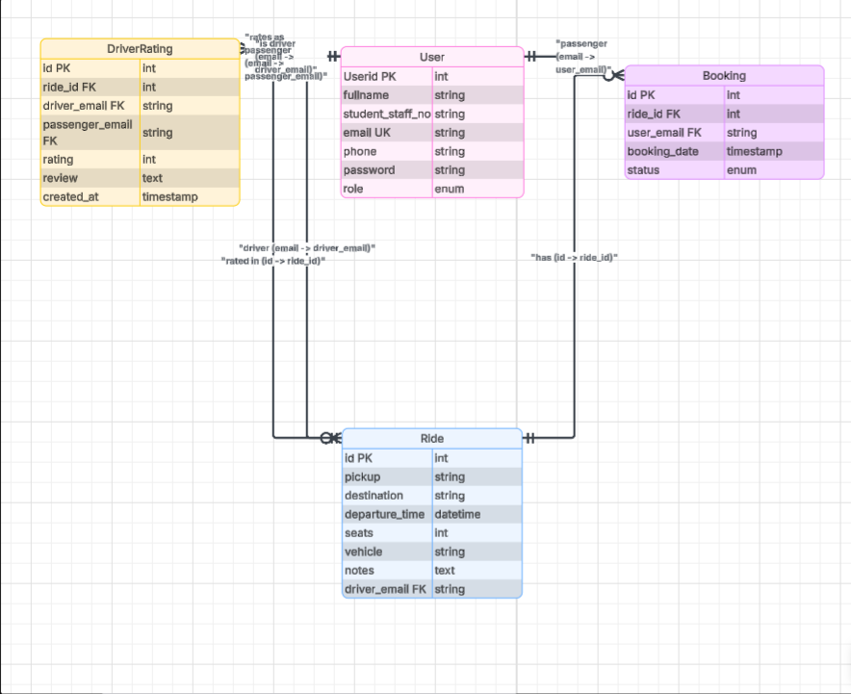

System Architecture overview

1. Presentation Layer (Frontend)
Web app
Used by: Students, Drivers, Admin
Handles: User input (registration, booking, login),Displaying shuttle info, maps, and tracking

2. Application Layer (Backend / Server)
Handles: Authentication (login/register), Booking management, Payment processing, GPS tracking updates, Communication between services

3. Data Layer (Database)
Stores all system data: Users (student, drivers, admin) Bookings, Payments Shuttle details Ratings & feedback

4. External Systems Integration
Payment Gateway: Processes student payments securely
Map/GPS Service: Provides real-time shuttle tracking and location update

User interface design
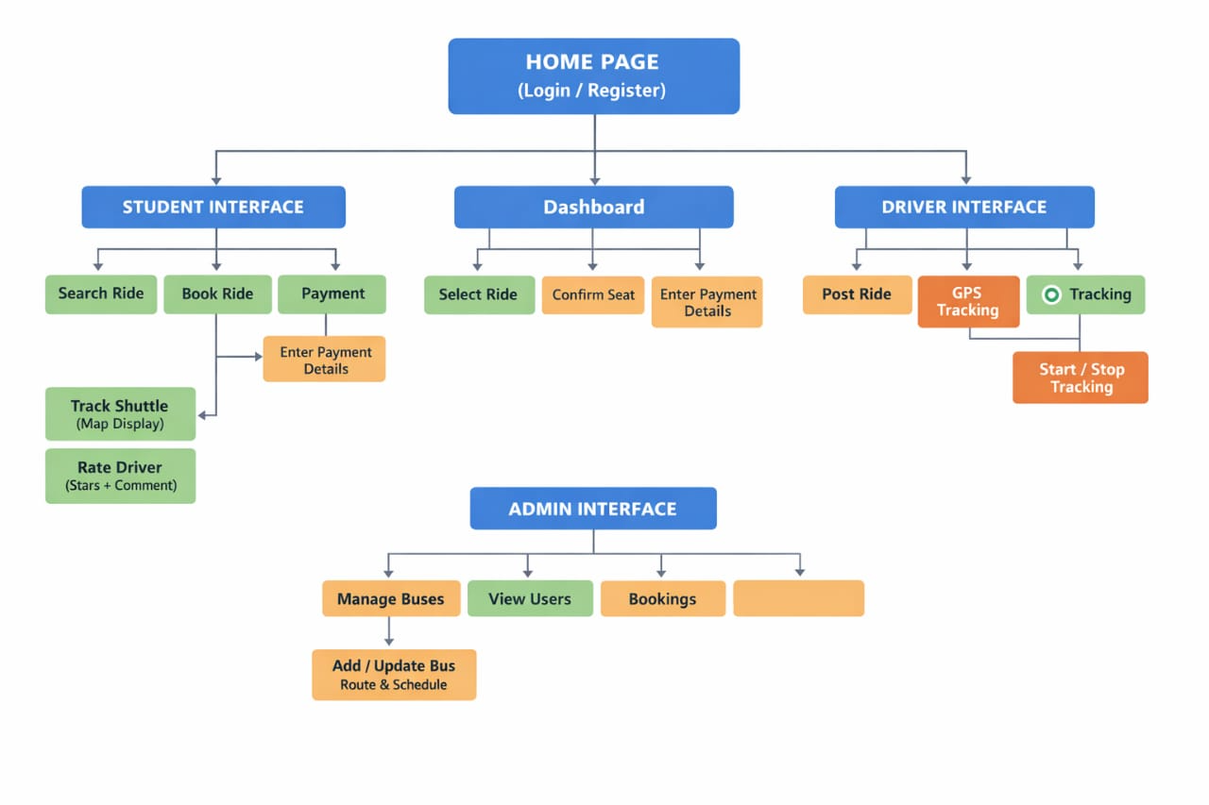

6.Technology Stack:

The Smart Campus Transportation Management System was developed using a simple and suitable technology stack.
Frontend: The frontend was built using HTML, CSS, and JavaScript. HTML was used to structure the pages, CSS was used for styling, and JavaScript was used for interactivity. The Google Maps JavaScript API was also used for address autocomplete.
Backend: The backend was developed using Python and Flask. Python was used as the main programming language, while Flask was used for routing, handling forms, managing sessions, and rendering templates. Werkzeug was used for password hashing and password verification to improve security.
Database: SQLite was used as the database because it is lightweight, easy to use, and integrates well with Flask.
Template Engine:Jinja2 was used as the templating engine to render dynamic HTML pages.

7.System implementation
The Smart Campus Transportation Management System was developed as a Flask-based web application using a structured architecture that separates routes, models, and templates. This structure helped organize the application and made it easier to manage the frontend, backend logic, and database interactions.
Application Structure (Routes, Models, Templates)
The application uses Flask routes to handle navigation and user requests. Routes were created for key system functions such as user registration, login, posting rides, searching for rides, and viewing available rides. These routes connect the frontend pages with the backend logic and control how users interact with the system.
Models were used to manage and store data in the SQLite database. The database stores information such as user accounts, ride details, and bookings. Using models allowed the system to organize data in a structured way and retrieve it when needed.
Templates were created using HTML, CSS, JavaScript, and Jinja2. HTML was used to structure the web pages and forms, CSS was used for styling the interface, and JavaScript was used to add interactivity. Jinja2 was used to render dynamic data from the backend onto the frontend pages.
Key System Features
The system includes several important features to support campus transportation. These include user registration and login, posting rides, searching for rides based on location and time, and viewing available rides. Users can submit ride details using forms and browse ride options provided by other users.
The system also integrates the Google Maps JavaScript API for address autocomplete, which helps users enter pickup and drop-off locations more easily. Security was implemented using Werkzeug for password hashing and password verification to protect user credentials.
Screenshots:
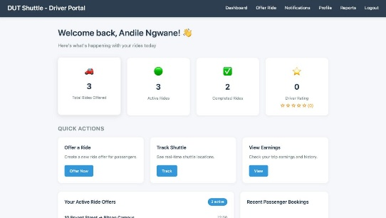
This is the driver portal where they can see what happening with their rides.

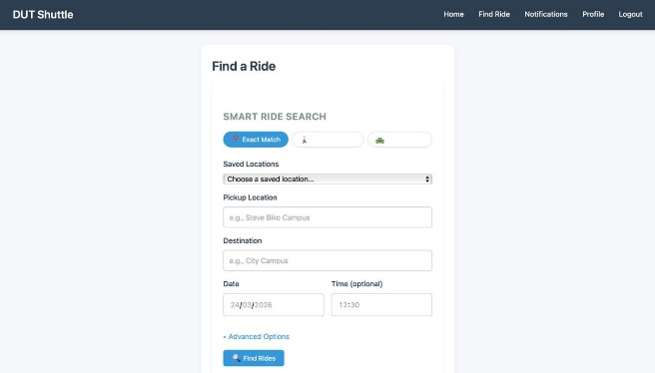
This is a page for finding rides that are available

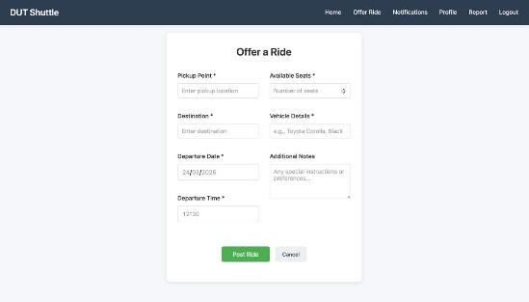
This is the page where rides are offered

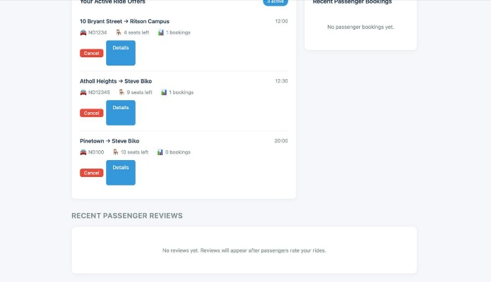
This is the page where driver can see their active rides

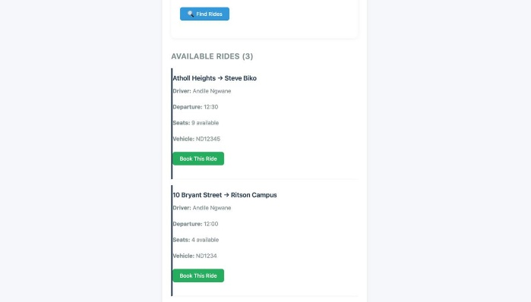
This is where students can see which rides are available so that they can book

8. Security and Data Management:
The system includes basic security measures to protect user data and control access. User authentication was implemented through registration and login, with access to certain features restricted based on whether a user is logged in and their role in the system.
Passwords were secured using Werkzeug password hashing, which means passwords were not stored in plain text but as secure hashed values in the database.
Input validation was applied to forms to ensure that users enter correct and safe data. This helps reduce errors and provides basic protection against common vulnerabilities such as invalid input.
The system also considered POPIA compliance by collecting only necessary user information, protecting sensitive data such as passwords, and limiting access to personal information to authorized users only.

9.Formal Testing Report

1.Application Setup Testing The application setup by installing Flask and executing the required files. I initialized the database using init_db.py and confirmed that the application started successfully when running app.py, with no startup errors observed.

2. User Functionality Testing The user features, including registration and login. I verified that the registration form correctly handles both valid and invalid inputs. I also tested user authentication and confirmed that login and logout processes function correctly, with proper session handling.

3. Admin Login & Dashboard Testing The admin login using valid credentials and confirmed that access to the admin dashboard is restricted to authorized users only. I verified that, once logged in, the administrator can view and manage users and ride data effectively.

4. Ride Management Testing The ride management features by adding new rides and confirming that they are displayed correctly. I also tested the search and filtering functionality to ensure that users can easily locate specific rides.

5. User Interface Testing The user interface by navigating through all pages. I confirmed that all page’s load correctly, with no broken links. I also verified that the navigation is smooth and that the CSS styling loads properly from the static folder.

6. Error & Exception Testing The various error scenarios, including missing templates and database-related issues. I confirmed that the application handles these situations appropriately. I also tested how the system responds to invalid user inputs and verified that it does not crash.

7. Security Testing The basic security features of the application. I confirmed that user authentication is enforced and that unauthorized access to admin pages is restricted. I also verified that input validation is implemented to reduce the risk of incorrect or harmful data entry.

8. Conclusion In conclusion, The Campus Carpool web application and found that it performs effectively across its core functionalities. Both user and administrative features operate reliably. Although minor issues may occur due to configuration or input validation, these can be addressed with minimal effort. Overall, the system is stable, functional, and suitable for its intended purpose.

10. Deployment

11. Source code Repository

12.Conclusion

The Smart Campus Transportation Management System successfully achieved its main goal of providing a safer, more reliable, and more convenient way for students and staff to access campus transport services. The system allows users to register securely, search and book rides, post available rides, and receive notifications, while also improving communication between users and transport services.
The system addresses the problem of transport inefficiency, limited ride coordination, and safety concerns by creating a centralized platform where transport options can be managed more effectively. It improves accessibility, reduces uncertainty, and supports.

